Xingyu Huang (001582498)

**Program Structures & Algorithms**

**Fall 2021**

**Assignment No. 2**

* **Task (List down the tasks performed in the Assignment)**
* **Relationship Conclusion: (For ex : z = a * b)**

The more disordered the array, the more time it takes to sort.

Approximate expression：

sorted: y = 2E-05x + 1

Random: y = 98.466e9E-05x

Part_random : y = 39.141e0.0001x

Reversed: y = 105.5e0.0001x

* **Evidence to support the conclusion:**

**Output (Snapshot of Code output in the terminal)**

1. **Graphical Representation(Observations from experiments should be tabulated and analyzed by plotting graphs(usually in excel) to arrive on the ßrelationship conclusion)**

The unit of time is milliseconds

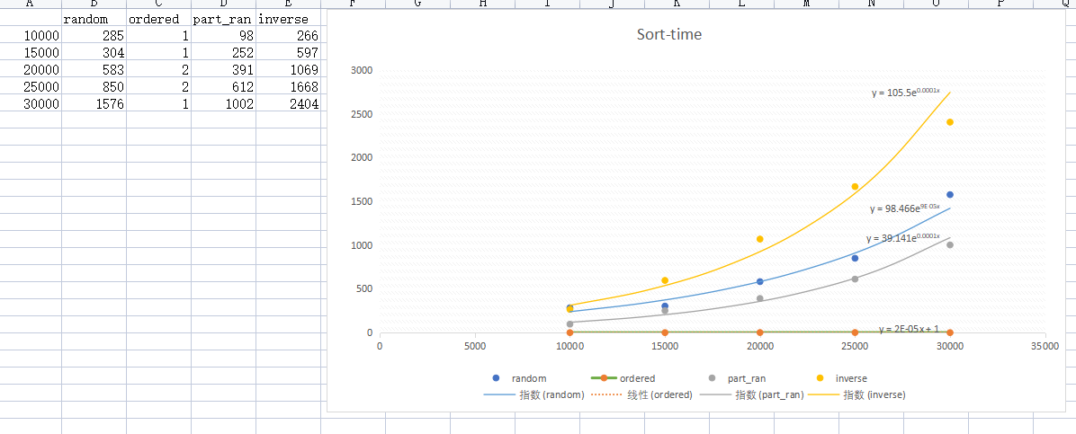

* **Unit tests result:(Snapshot of successful unit test run)**

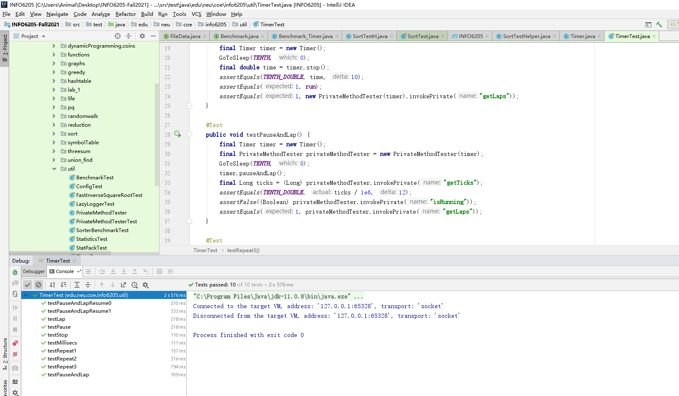

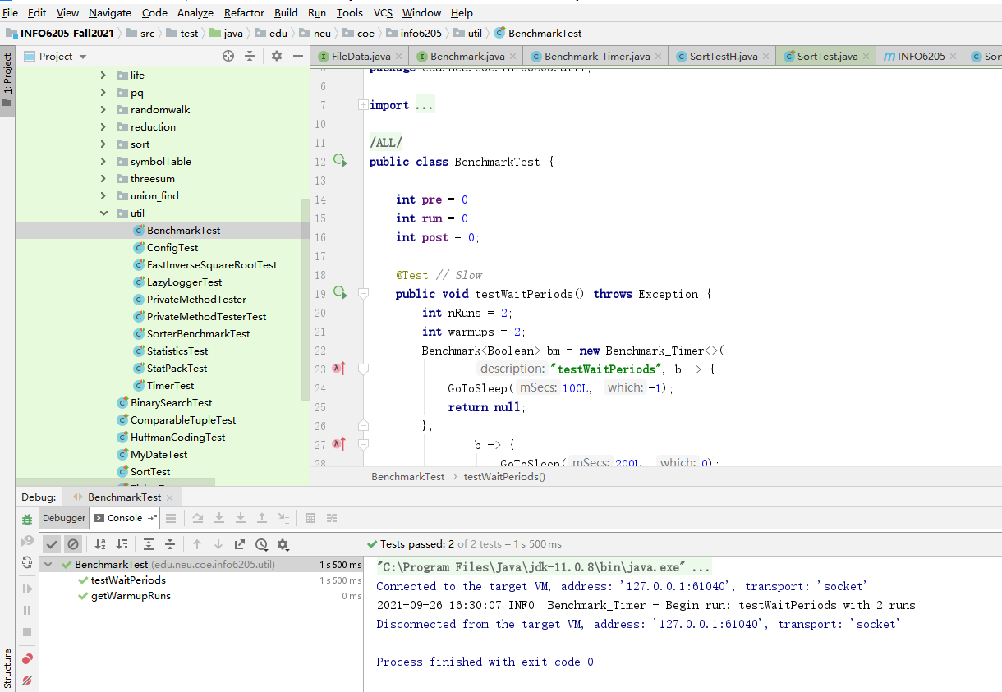

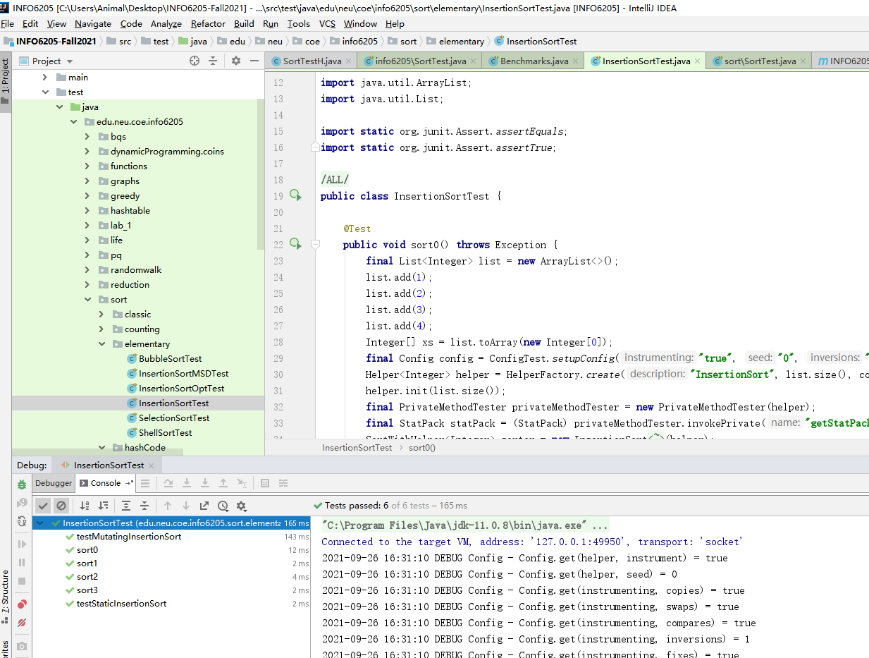

For task 3, I have made a unit test by myself, and tested 4 differents kinds of sorted arrays（ordered，random，part_random,inversed）with 5 different lengths of element in every test，the snap shot is the location of my unit test file and the success result, and it is where I get original data resource for my statistic graph.

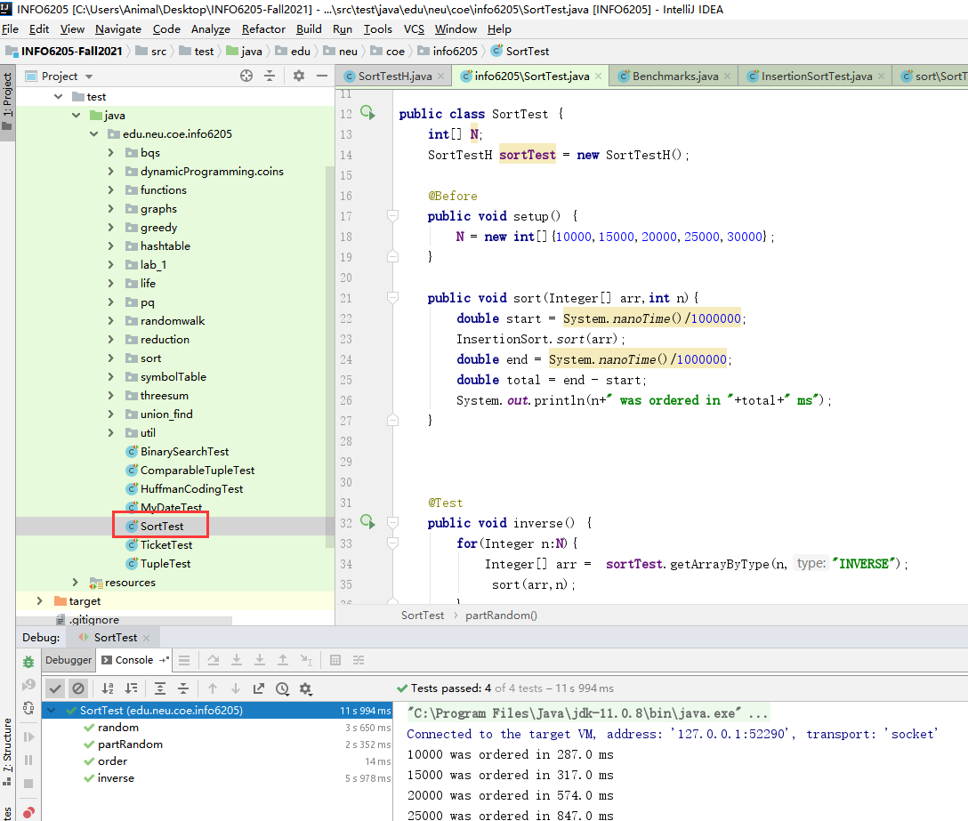

3.Your ****code**** (*RandomWalk.java* plus anything else that you changed or created);